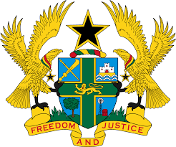

STATEMENT DELIVERED BY MR. FRANCIS D. KOTIA,
DEPUTY PERMANENT REPRESENTATIVE, ON BEHALF OF GHANA AT THE 37TH SESSION OF THE HUMAN RIGHTS COUNCIL
TUESDAY, 19TH JANUARY 2021

REVIEW OF MAURITANIA

Thank you, Madam President,
We welcome the delegation of Mauritania to the UPR Working Group.
Ghana acknowledges the significant progress made by Mauritania in enhancing its legal framework for the promotion and protection of human rights through the adoption of a number of laws such as the National Police Regulations Act, among other laws.
We recommend the following:
- Continue to reinforce international and domestic laws to ensure equal rights between men and women, in particular with regards to tranfer of nationality to children and spouses as well as the right to own and inherit land;
- Intensify efforts to fully implement legislations that seek to protect the rights of migrant workers and members of their families and lastly,
- Consider to adopt a comprehensive strategy to eliminate all forms of discriminations against the vulnerable population, including children from minority groups and children with disabilities.

We wish Mauritania a successful review outcome.

I thank you.

