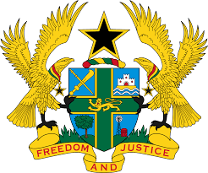

STATEMENT DELIVERED BY MR. FRANCIS D. KOTIA,
DEPUTY PERMANENT REPRESENTATIVE, ON BEHALF OF GHANA
AT THE 37TH SESSION OF THE HUMAN RIGHTS COUNCIL
TUESDAY, 26TH JANUARY 2021

REVIEW OF GEORGIA

Thank you, Madam President.
Ghana welcomes Georgia to the UPR Working Group.
We commend the steps taken by the Government to improve standards of human rights protection, including the adoption and implementation of the National Human Rights Strategy (2014-2020) and governmental action plans that seek to protect human rights in Georgia.
Ghana submits the following recommendations:

- Continue with all on-going efforts to ratify outstanding core international Human Rights Instruments;
- Consider enacting a comprehensive legislation that provides full and effective protection against the elimination of hate speech, in particular in the social media and lastly;
- Take steps to ensure the empowerment of women in Georgia by considering to ensure that women are well represented in senior and high decision-making positions and political bodies.
Our delegation wishes Georgia every success with the UPR.

I thank you.

