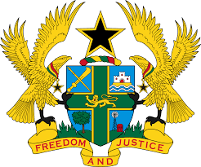

STATEMENT BY GHANA DELIVERED BY H.E RAMSES JOSEPH CLELAND,
AMBASSADOR AND PERMANENT REPRESENTATIVE,
MONDAY 18TH JANUARY 2021

REVIEW OF THE FEDERATED STATES OF MICRONESIA

Thank you, Madam President.
Ghana extends a warm welcome to the distinguished delegation of the Federated States of Micronesia to the UPR Working Group.
My delegation commends the steps taken by the Government since the last UPR to promote and protect human rights. Of note is the establishment of the nationwide integrated disaster risk management and climate change policy of June 2013 and the Strategic Development Plan (2004–2023). We further commend the ratification of Convention on the Rights of Persons with Disabilities.
In the spirit of constructive dialogue Ghana has the following recommendations:
- Intensify its efforts made to prevent incidents of suicide among children, including those with disabilities, by providing adequate and comprehensive psychological counselling services in schools and communities;
- Consider establishing an independent national human rights institution to protect and promote especially women’s human rights in the country and finally;
- Consider ratifying outstanding International treaties and conventions, including the UN Convention against Torture and Other Cruel, Inhuman or Degrading Treatment or Punishment (UNCAT) at the earliest convenience.
Ghana wishes the Federated States of Micronesia every success with the review process.
I thank you.

