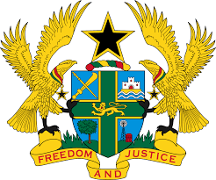

STATEMENT DELIVERED BY MR. FRANCIS D. KOTIA,
DEPUTY PERMANENT REPRESENTATIVE, ON BEHALF OF GHANA AT THE 37TH SESSION OF THE HUMAN RIGHTS COUNCIL, FRIDAY 22ND JANUARY, 2021

REVIEW OF AUSTRIA

Thank you Madam, President.
Ghana welcomes Austria to the UPR Working Group.
My delegation commends the steps taken by the Government since their last UPR to promote and protect human rights in the country, and note with commendation the adoption of the law amending the Code of Criminal Procedure in 2016 and the Juvenile Courts Acts in 2015.
We recommend the following to Austria:
- Take measures to address allegations of excessive use of force and ill-treatment by police through the establishing an independent and effective investigations and complaints mechanism;
- Intensify efforts to promote equal opportunities in access to education for Roma children at all levels and finally ;
- Consider enacting a comprehensive legislation that provides full and effective protection against the elimination of hate speech.

We wish Austria every success with the UPR.

I thank you.

