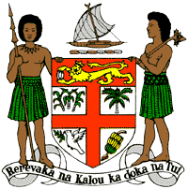
PERMANENT MISSION OF THE REPUBLIC OF FIJI TO THE UNITED NATIONS
OFFICE AND OTHER INTERNATIONAL ORGANISATIONS AT GENEVA
37TH SESSION OF THE UPR WORKING GROUP
[Republic of Rwanda]

Fiji welcomes the delegation of the Republic of Rwanda and extends its congratulations for the achievements in implementing the recommendations from the previous cycle.
Fiji commends the Republic of Rwanda for taking concrete steps to improve its prevention and response to cases of gender-based violence, including by establishing Isange One Stop Centres to assist victims.
Fiji offers the following recommendations:
- Intensify efforts to develop and strengthen the necessary legislative frameworks that address cross-sectoral environmental challenges, including climate change adaptation and mitigation frameworks, and ensure that women, children, persons with disabilities, minority groups and local communities are meaningfully engaged in their implementation.
- Continue to ensure that all instances of death in custody, including during police arrests and at police stations, are impartially and effectively investigated and that all perpetrators are prosecuted.
- Continue to make advances in establishing frameworks to effectively identify child victims of human trafficking and provide them with appropriate medical and psychosocial services.
We wish the delegation every success in its review.

