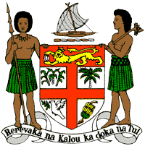
PERMANENT MISSION OF THE REPUBLIC OF FIJI TO THE UNITED NATIONS
OFFICE AND OTHER INTERNATIONAL ORGANISATIONS AT GENEVA
37TH SESSION OF THE UPR WORKING GROUP
[Mauritania]

Fiji welcomes the delegation of Mauritania and congratulates the delegation for the development of its national action plan for the implementation of the recommendations from its second cycle review, to the drafting and submission of its national report under this third review.
Fiji also commends Mauritania for its First Priorities social programme which aims to meet the most pressing needs of its people.
Fiji offers the following recommendations:
- Intensify efforts to develop and strengthen the necessary legislative frameworks that address cross-sectoral environmental challenges, including climate change adaptation and mitigation frameworks, and ensure that women, children, persons with disabilities and indigenous and local communities are meaningfully engaged in its implementations;
- Maintain the current de facto moratorium on the death penalty and take positive steps to abolish the death penalty;
- Strengthen efforts to remove barriers preventing access by children with disabilities to social protection, health care services and an inclusive, quality education system; and
- Continue to strengthen efforts to improve access to health care for all, including access to sexual and reproductive health-care services and information.
I thank you.

