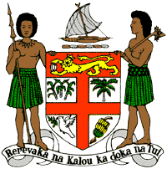
PERMANENT MISSION OF THE REPUBLIC OF FIJI TO THE UNITED NATIONS
OFFICE AND OTHER INTERNATIONAL ORGANISATIONS AT GENEVA
37TH SESSION OF THE UPR WORKING GROUP
[Georgia]

Fiji welcomes the delegation of Georgia and extends its congratulations for the achievements in implementing the recommendations from the previous cycle.
Fiji commends Georgia for adopting the Code on the Rights of the Child and for its commitment to child protection and welfare through its vision for the development and implementation of tailored educational, healthcare and social security programmes.
Fiji offers the following recommendations:
- Continue efforts to develop and strengthen the necessary legislative frameworks that address cross-sectoral environmental challenges, including climate change adaptation and mitigation frameworks, and ensure that women, children, persons with disabilities, minority groups and local communities are meaningfully engaged in their implementation.
- Continue to strengthen efforts to combat discrimination, including on grounds of gender, sexual orientation, religion or belief, and disability, including through public awareness campaigns combating hate speech and stigma.
- Continue to strengthen efforts to ensure that all instances of racist hate crimes are effectively and impartially investigated, that perpetrators of such crimes are prosecuted, and that victims are provided with adequate and appropriate redress.
We wish the delegation every success in its review.

