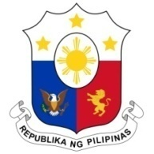
PHILIPPINES

Human Rights Council
37th Session of the Working Group on the Universal Periodic Review
20 January 2021, Palais des Nations, Geneva, Switzerland

SAINT LUCIA

Speaking Time: 1 min 50

Thank you, Chair.

The Philippines warmly welcomes the delegation of Saint Lucia to the third cycle UPR and thanks it for the presentation of the national report.

We laud Saint Lucia’s recent efforts to strengthen its anti-human trafficking legislation. We also commend its recent ratification of the Convention on the Rights of Persons with Disabilities in 2020.

In a constructive spirit, the Philippines presents the following recommendations for consideration by Saint Lucia:

- Take concrete steps towards the ratification of core international human rights instruments, including the ICCPR and the ICESCR;

- Consider the implementation of human rights education and training initiatives; and

- Strengthen implementation of its National Action Plan against human trafficking, commensurate to its efforts to legislate more robust penalties on traffickers.
We wish Saint Lucia a successful review.

Thank you, Chair. END.

