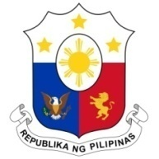
PHILIPPINES

Human Rights Council
37th Session of the Working Group on the Universal Periodic Review
21 January 2021, Palais des Nations, Geneva, Switzerland

NEPAL

Speaking Time: 1 min 05

Thank you, Chair.

The Philippines warmly welcomes the delegation of Nepal to the third cycle UPR and thanks it for the presentation of the national report.

We laud Nepal’s active efforts in expanding human rights education and training for its public officials, including the judiciary, military and law enforcement agencies. We likewise commend its progress in combating human trafficking, through the filing of cases in courts as well as programs for rehabilitation and reintegration of survivors.

In a constructive spirit, the Philippines presents the following recommendations for consideration by Nepal:

- Consider the ratification of the International Convention on the Protection of the Rights of All Migrant Workers and Their Families;

- Ensure that its efforts to address poverty are inclusive, gender-responsive, and human rights-based; and

- Strengthen implementation of legislation against gender-based violence and certain traditional practices that are considered harmful towards women and girls.

We wish Nepal a successful review.

Thank you, Chair. END.

