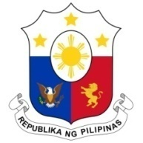
PHILIPPINES

Human Rights Council
37th Session of the Working Group on the Universal Periodic Review
22 January 2021, Palais des Nations, Geneva, Switzerland

AUSTRIA

Speaking Time: 1 minute

Thank you, Chair.

We warmly welcome the delegation of the Republic of Austria to the third cycle UPR and we thank it for the presentation of its national report.

We welcome measures taken by Austria to address racism, xenophobia and discrimination, taking particular note of its programs against anti-semitism and Islamophobia, as well as programs on the integration of minorities. We also welcome its efforts to ensure a victim-oriented approach to its comprehensive programs to combat human trafficking.

In a constructive spirit, the Philippines presents the following recommendations for consideration by Austria:

- Take further steps towards effective access to education and apprenticeship opportunities for asylum seekers, including those who are no longer minors;

- Establish a mechanism to ensure independent and competent legal counsel for asylum seekers; and

- Consider the ratification of the CMW (International Convention on the Protection of the Rights of All Migrant Workers and Their Families).

We wish Austria a successful review.

Thank you, Chair. END.

