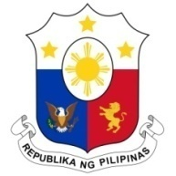
PHILIPPINES

Human Rights Council
37th Session of the Working Group on the Universal Periodic Review
20 January 2021, Palais des Nations, Geneva, Switzerland

AUSTRALIA

Speaking Time: 0 min 55

Thank you, Chair.

The Philippines warmly welcomes the delegation of the Commonwealth of Australia to the third cycle UPR and thanks it for the presentation of the national report.

We welcome Australia’s efforts to expand support for human rights education and training of law enforcement officials handling migration, and other steps taken to protect refugees, asylum seekers and migrants.

In a constructive spirit, the Philippines presents the following recommendations for consideration by Australia:

- Strengthen implementation of the OPCAT through the establishment of National Preventive Mechanisms;

- Ratify key international human rights instruments such as the ICRMW;

- Ensure adequate resources for programs aimed at raising health and quality-of-life indicators for Aboriginal and Torres Strait Islander communities; and

- Continue its efforts to improve living conditions in immigration detention or processing centers.
We wish Australia a successful review.

Thank you, Chair. END.

