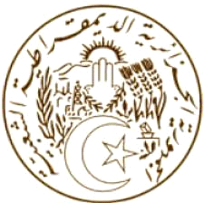

الجـمهــوريـــة الجـــزائريـــة الـــديمـقراطيــة الشــعبيـــة
REPUBLIQUE ALGERIENNE DEMOCRATIQUE ET POPULAIRE
MISSION PERMANENTE D’ALGERIE  AUPRES DE L’OFFICE DES NATIONS UNIES  A GENEVE ET DES ORGANISATIONS  INTERNATIONALES EN SUISSE |  | البعثة الدائمة للجزائر  لدى مكتب الأمم المتحدة بجنيف  والمنظمات الدولية بسويسرا

Statement by Algeria
United Nations Human Rights Council
37th session of the Working Group on the Universal Periodic Review

Review of Myanmar
22 January 2021

Thank you, Madame President.

Algeria welcomes the Myanmar delegation to the third cycle of the UPR and also welcomes the measures taken by this country to implement the recommendations accepted during the second cycle of the UPR, in particular the ratification of the International Covenant on Economic, Social and Cultural Rights and the Optional Protocol to the Convention on the Rights of the Child on the involvement of children in armed conflict.

Algeria would like to make the following recommendations:

- Consider the option of ratifying the International Covenant on Civil and Political Rights and the International Convention on the Elimination of All Forms of Racial Discrimination;

- Consider introducing at least one year of free and compulsory pre-primary education and ensure at least nine years of free and compulsory education;
- Continue to promote the right to education, including ensuring equal access to education for vulnerable groups;

Thank you, Madame President.

