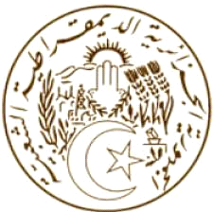
الجـمهــوريـــة الجـــزائريـــة الـــديمـقراطيــة الشــعبيـــة
REPUBLIQUE ALGERIENNE DEMOCRATIQUE ET POPULAIRE
MISSION PERMANENTE D’ALGERIE  AUPRES DE L’OFFICE DES NATIONS UNIES  A GENEVE ET DES ORGANISATIONS  INTERNATIONALES EN SUISSE |  | البعثة الدائمة للجزائر  لدى مكتب الأمم المتحدة بجنيف  والمنظمات الدولية بسويسرا
Statement by Algeria
United Nations Human Rights Council
37th session of the Working Group on the Universal Periodic Review
Review of Georgia
26 January 2021
Thank you, Madame President.

Algeria warmly welcomes the delegation of Georgia to the third cycle of the UPR process. We thank the delegation for a comprehensive national report. Algeria commends Georgia for the constitutional amendments introduced in 2017-2018, specifically focus on social rights, rights of persons with disabilities and child rights.
Algeria would like to make the following recommendations:

- Consider allocating a necessary human, technical and financial resources to institutions in charge of monitoring the implementation of the law on the elimination of all forms of discrimination, especially to “the Office of the Public Defender”;

- Carry out a comprehensive study to assess the scope, nature and root causes of the presence of children in street situations in the country in order to develop a national prevention policy;

- Guarantee the equal rights of children with disabilities to health, education, protection, justice, participation and family life;

- Continue to promote economic and social development in accordance with the national development plan, and better promote and protect human rights;

I thank you, Madam President.

