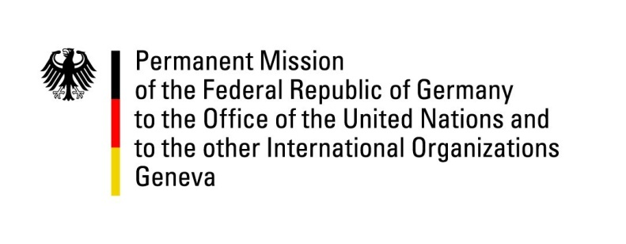

United Nations Human Rights Council

37th Session of the UPR Working Group

Geneva, 20 January 2021

German Recommendations and advance questions to
St. Lucia

Thank you Vice President,
Germany welcomes the delegation of St. Lucia and commends St. Lucia for its effective efforts in protecting the health and lives of its citizens during the Covid-19 pandemic.

Germany remains concerned about the continued existence of the death penalty in St. Lucia and about the continuing criminalization of consensual sexual activity between persons of the same sex.

Germany therefore recommends to:
- immediately introduce an official moratorium on the death penalty;

Ratifications of key human rights conventions are an important step in ensuring the promotion and protection of human rights.

- ratify the Second Optional Protocol to the International Covenant on Civil and Political Rights, aiming at abolition of the death penalty and to immediately introduce an official moratorium;
- ratify the Convention against Torture and other Cruel, Inhuman or Degrading Treatment and Punishment;
- ratify the International Convention for the Protection of All Persons from Enforced Disappearance.

Thank you, Madam President.
GERMAN ADVANCE QUESTIONS TO ST. LUCIA:
- What steps has St. Lucia taken towards the ratification of the UN Convention against Torture and other Cruel, Inhuman or Degrading Treatment and Punishment (CAT)? Does the Government have a timeframe for when to become a party to this treaty?
- What measures does St. Lucia take to reduce domestic violence, including with regard to child abuse?
- How does the Health and Family Life Education Program ensure to promote gender equality, information on non-discrimination, violence and gender-based violence, consent and bodily integrity, sexual abuse and harmful practices?
- What steps has St. Lucia taken to introduce legal and practical measures to eliminate discrimination against people from the LGBTI community?

