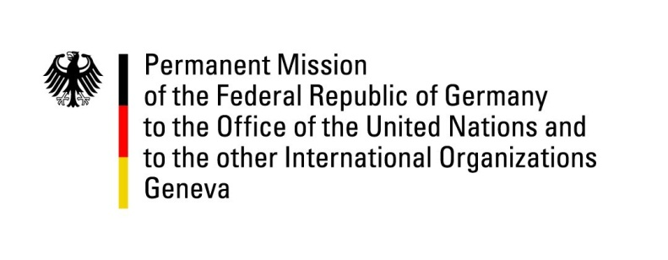

United Nations Human Rights Council

37th Session of the UPR Working Group

Geneva, 19 January 2021

German Recommendations and advance questions to
St. Kitts & Nevis

Madam President,
Germany welcomes the delegation of St. Kitts & Nevis. We commend St. Kitts & Nevis for its effective efforts in protecting the health and lives of its citizens during the Covid-19 pandemic and for having ratified the Convention against Torture and other Cruel, Inhuman or Degrading Treatment or Punishment in 2020 and the Convention on the Rights of Persons with Disabilities in 2019.

Germany remains concerned about the continued existence of the death penalty in St. Kitts and Nevis and about the continuing criminalization of consensual sexual activity between persons of the same sex.

Germany recommends to:
- Immediately introduce an official moratorium on the death penalty.
- Ratify the International Covenant on Civil and Political Rights and especially its Second Optional Protocol, aiming at the abolition of the death penalty;
- Pass anti-discrimination legislation in order to prohibit discrimination on grounds of gender identity and sexual orientation;
- Ensure unhindered access to sexual and reproductive health services and rights, including for adolescents.

Thank you, Madam President.
GERMAN ADVANCE QUESTIONS TO ST KITTS AND NEVIS:
- Which measures has St. Kitts and Nevis taken to reduce the continuing high rates of domestic violence, including sexual abuse against children, also in view of the global increase of domestic violence during the Covid-19 pandemic?
- After ratification of the Convention against Torture and other cruel, inhuman or degrading treatment or punishment, which concrete steps will St. Kitts and Nevis take to implement it?
- St. Kitts and Nevis noted Germany’s recommendations to ratify the International Covenant on Civil and Political Rights and its Optional Protocols (UPR 2015) and to abolish the death penalty (UPR 2011). What are the reasons why St. Kitts and Nevis has not abolished the death penalty yet?

