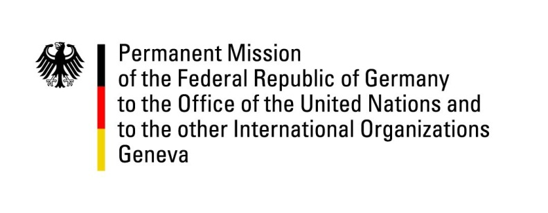

United Nations Human Rights Council

37th Session of the UPR Working Group

Geneva, 21th of January 2021

German Recommendations to
Nepal

Madam President,
Germany commends Nepal for improving the conditions for Bhutanese refugees but remains concerned about the rights of vulnerable groups.
Germany recommends to:
- Bring the Enforced Disappearance Enquiry Truth and Reconciliation Act into compliance with the Supreme Court ruling and international standards, in particular include survivors of sexualized violence and their families in the transitional justice process and all related government schemes.
- Abolish the statute of limitations for rape, bring existing legislation on rape into accordance with international standards and enforce legislation on domestic violence and harmful practices.
- Develop effective mechanisms to implement the Cast-based Discrimination and Untouchability (Crime and Punishment) Act.
- Ratify OP-CAT
- Amend the Citizenship Act to enable citizenship documentation at birth and to repeal gender discriminatory provisions.

Thank you.

