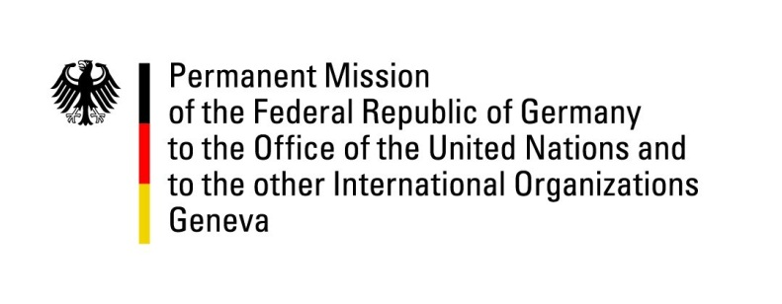

United Nations Human Rights Council

37th Session of the UPR Working Group

Geneva, 27th of January 2021

German Recommendations to
Nauru

Madam President,
Germany welcomes the delegation of Nauru and commends Nauru for abolishing the death penalty and for decriminalizing same-sex relations.

Germany remains concerned about restrictions on freedom of information in Nauru.

Germany recommends to:
- Ratify the International Covenant on Civil and Political Rights and the International Covenant on Economic, Social and Cultural Rights.
- Immediately reinstate mental health services for refugees and asylum seekers as well as locals, provided by Médecins sans Frontières (MSF) and other qualified health providers.
- Protect and uphold the freedom and independence of the media in Nauru, including by removing prohibitively high visa fees for foreign journalists, in order to enable foreign journalists to visit the country.
- Amend the Criminal Code to lift restrictions on the freedom of movement, freedom of assembly and freedom of expression.
- Establish a national human rights institution in accordance with the Paris Principles.

Thank you, Madam President.

