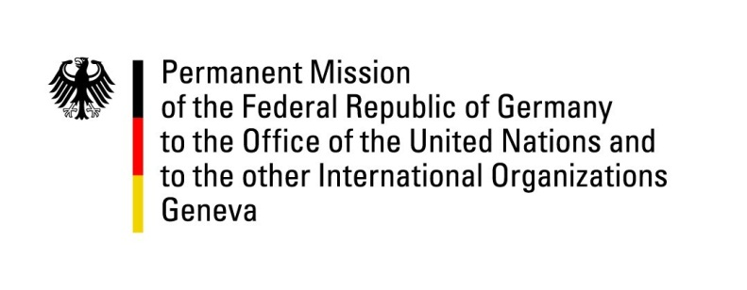

United Nations Human Rights Council

37th Session of the UPR Working Group

Geneva, 25th of January 2021

German Recommendations to
Myanmar

Madam President,
Germany commends Myanmar for progress regarding children’s rights but remains concerned about human rights violations particularly against the Rohingya.

Germany recommends to:
- Ratify the ICCPR and its 2nd Optional Protocol, the CAT and OP-CAT, CERD and CED.
- Cooperate fully with UN human rights mechanisms, including by granting full access to the Special Rapporteur on Myanmar and to the IIMM.
- Repeal section 77 of the Telecommunications Law to bring it in line with international human rights standards and ensure that any restrictions on service in emergency times are clearly defined in law, necessary and proportionate, subject to prior judicial approval, and strictly time-limited.
- Operationalize the Women Peace and Security agenda.

Thank you, Madam President.

