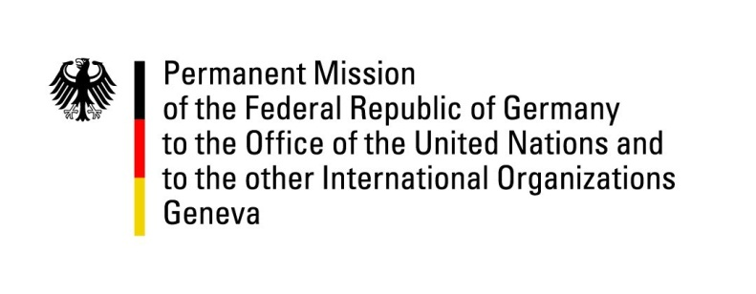

United Nations Human Rights Council

37th Session of the UPR Working Group

Geneva, 27th of January 2021

German Recommendations and advance questions to
Georgia

Madam President,
Germany welcomes the delegation of Georgia and commends Georgia for progress made regarding the reform of the judicial and penal system as well as the improvement of prison conditions.

Furthermore, we welcome the adoption and implementation of the Child Rights Code.

However, Germany is concerned about hate speech against minorities and human rights defenders online and offline.

Germany recommends to:
- Ratify the European Charter for Regional and Minority Rights;
- Adopt, without delay, national legislation on domestic violence and create public institutions that offer assistance and protection for victims of domestic and sexual violence;
- Take steps to effectively prevent hate speech and strengthen efforts to properly enforce legislation prohibiting agitation, particularly against racial, religious and ethnic minorities.

Thank you, Madam President.

GERMAN ADVANCE QUESTIONS TO GEORGIA:
- When does Georgia expect the new human rights strategy for the period after 2020 to be adopted? What are its priorities?
- In July 2018, the Georgian Constitutional Court ruled the privileged position of the Georgian Orthodox Church vis-à-vis other religious groups to be unconstitutional. When does Georgia intend to adopt corresponding new regulations and which aspects will be addressed?
- A major challenge remains the negative attitude towards LGBTI persons in large parts of society. LGBTI activists who wanted to exercise their right to assembly were confronted with violence or threats of violence in the past. Is Georgia planning to take measures to reduce prejudice against LGBTI persons?

