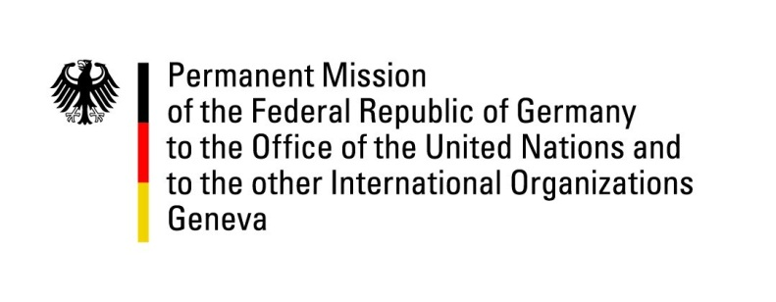

United Nations Human Rights Council

37th Session of the UPR Working Group

Geneva, 20th of January 2021

German Recommendations to
Australia

Madam President,
Germany welcomes the delegation of Australia and commends Australia for removing children and their families and other individuals at risk from immigration detention centers, as agreed to during the previous UPR cycle.

Germany remains concerned about the scope of immigration detention.

Germany therefore recommends to:
- Ensure immigration detention is justified, time limited, and subject to prompt and regular judicial oversight.
- Raise the minimum age of criminal responsibility to at least 14 years.
- Adopt uniform legislation prohibiting sterilization of people with disability without their consent.

Thank you, Madam President.

