Mission Permanente  du Royaume du Maroc  Genève | 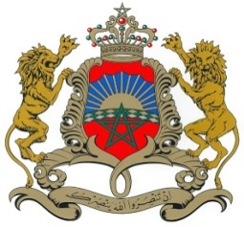

37ème Session de l’Examen Périodique Universel
Déclaration du Royaume du Maroc
Examen de Saint Lucie
20 janvier 2021

Mr. Vice-President,

The Kingdom of Morocco welcomes Saint-Lucia’s participation in the UPR and notes the positive steps taken since its last review.
Morocco welcomes the introduction by the GOST of the income support programme to non-contributors of National Insurance Corporation who became unemployed due to the impact of the the Covid-19 Pandemic.
My delegation welcomes the accession of the Government of Saint-Lucia to the WIPO Marrakech Treaty which provides access to reading material to persons who are print disabled.
Finally, Morocco would like to recommend the consideration of the ratification of the International Covenant on Civil and Political Rights and the International Covenant on Economic, Social and Cultural Rights,

Thank you Mr. Vice-President.

