Mission Permanente  du Royaume du Maroc  Genève | 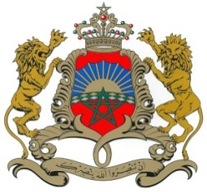

37ème Session de l’Examen Périodique Universel
Déclaration du Royaume du Maroc
Examen de Saint-Kitts and Nevis
19 janvier 2021

Mr. vice-President,

The Kingdom of Morocco welcomes Saint-Kitts and Nevis’s participation in the UPR and notes the positive steps taken since its last review.
Morocco welcomes the implementation by the Government of Saint-Kitts and Nevis of a national housing programme to improve the standard of living of its citizens
My delegation welcomes the launch by the Government of Saint-Kitts and Nevis of the social security Covid-19 Emergency Relief Fund who benefited over 9500 citizens who suffered a loss of income due to the Coronavirus pandemic.
Finally, Morocco would like to recommend to the Government of Saint-Kitts and Nevis to consider the ratification of the International Covenant on Civil and Political Rights and the International Covenant on Economic, Social and Cultural Rights.
Thank you Mr. vice-President.

