Mission Permanente  du Royaume du Maroc  Genève | 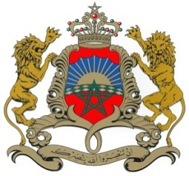

37ème Session de l’Examen Périodique Universel
Déclaration du Royaume du Maroc
Examen de la République d’Autriche
26 janvier 2021

Mr. vice President,

Morocco congratulates the Delegation of the Republic of Austria for the presentation of its national report under the 3rd cycle of the UPR.
While noting the positive steps taken since its last review, Morocco welcomes its close cooperation with all international and regional human rights protection mechanisms and monitoring bodies as well as its periodic reporting obligations.
My delegation welcomes the significant improvements made by Austria of its of legislative mechanisms and its institutional and structural framework especially trough structural prerequisites for tolerant and equal coexistence aiming in combating discrimination and intolerance.
Finally, Morocco would like to recommend the following:
Maintain efforts to further promote gender equality, combat violence against children, and eliminate poverty and social exclusion of children in Austria.

I thank you Mr. vice President.

