Mission Permanente  du Royaume du Maroc  Genève | 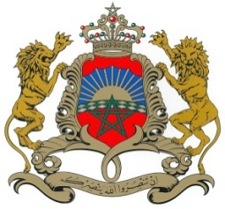

37ème Session de l’Examen Périodique Universel
Déclaration du Royaume du Maroc
Examen de l’Australie
20 janvier 2021

Mr. Vice-President,

The Kingdom of Morocco welcomes Australia’s participation in the UPR and notes the positive steps taken since its last review.
Morocco welcomes the ratification by the Australian Government of the Optional Protocol to the Convention against Torture and Other Cruel, Inhuman or Degrading Treatment or Punishment3 and the Paris Agreement.
My delegation welcomes the introduction by Australia of the social cohesion initiatives and multicultural diversity enabling all communities to become actively part of Australia’s economic and social development.
Finally, Morocco would like to recommend the consideration of the ratification of the International Convention on the Protection of the Rights of All Migrant Workers and Their Families.
Thank you Mr. Vice-President.

