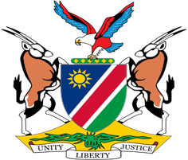

Statement by Mr. Colin Namalambo, Charge d’ Affaires, 37th session, UPR of Saint Lucia, 20 January 2021

- Thank You Madam President,

- Namibia welcomes the esteemed delegation of Saint Lucia and thank them for preparing a comprehensive national report.

- We have taken note of the measures by the Government of Saint Lucia to improve the human rights of its citizens. This includes the ratification on 11 June 2020 of the Convention on the Rights of Persons with Disabilities and the numerous measures taken to address violence against women and girls.

- Having taken note of the progress made, we make the following recommendations to Saint Lucia for consideration.

  - Ratify the International Covenant on Economic, Social and Cultural Rights and its Optional Protocol;

  - Ratify the International Covenant on Civil and Political Rights and its Optional Protocols;

- We urge the Office of the High Commissioner for Human Rights to provide the necessary technical assistance as requested by the Government of Saint Lucia.

- We wish the delegation a successful review.

- I thank you Madam President.

