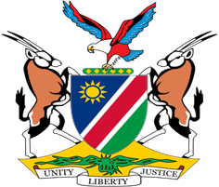

Statement by Mr. Colin Namalambo, Charge d’ Affaires, 37th session, UPR of Sao Tome and Principe, 27 January 2021

- Thank You Madam President,

- Namibia warmly welcomes the delegation of Sao Tome and Principe and thank them for their commitment to the UPR process.

- We are extremely pleased to note that Sao Tome and Principe is now a State Party to 8 out of the 9-core international human rights treaties, which is indicative of the Government’s commitment to promote and protect human rights in Sao Tome and Principe.

- We, however, also note that Sao Tome and Principe is yet to ratify some key optional instruments, and in the spirit of constructive dialogue we, therefore, make the following recommendations for consideration by Sao Tome and Principe:

  - Ratify the Optional Protocol to the Convention on the Rights of Persons with Disabilities;

  - Ratify the Optional Protocol to the Convention on the Rights of the Child on the sale of children, child prostitution and child pornography,

- We wish the delegation of Sao Tome and Principe a successful review.

- I thank you Madam President.

