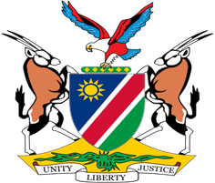

Statement by Mr. Colin Namalambo, Charge d’ Affaires, 37th session, UPR of Rwanda, 25 January 2021

- Thank You Madam President,

- Namibia warmly welcomes the delegation of Rwanda and thank them for the comprehensive national report as well as for their commitment to the UPR process.

- Namibia takes note with satisfaction of all the positive human rights measures taken by Rwanda since its last review in 2015. We particularly welcome the adoption of measures aimed at ensuring equality between men and women and the empowerment of women in Rwandan Society. There is, however, a margin for further improvement and we, therefore, make the following recommendations for consideration by Rwanda:

  - Enhance the implementation of existing legislation to prevent child marriage.

  - Strengthen efforts to combat all forms of gender-based violence against women, including domestic and sexual violence.

- We wish the delegation of Rwanda a successful review.

- I thank you Madam President.

