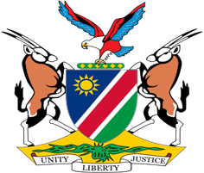

Statement by Mr. Colin Namalambo, Charge d’ Affaires, 37th session, UPR of Nepal, 21 January 2021

- Thank You Madam President,

- Namibia warmly welcomes the esteemed delegation of Nepal and thank them for the timely submission of their national report as well as for the information provided today.

- We applaud Nepal for its commitment to promote and protect the human rights of its citizens. We, among other things, welcome the adoption by Nepal of a fifth National Human Rights Action Plan 2020-2025, and measures aimed at eliminating poverty by the year 2043.

- In the spirit of constructive dialogue, we make the following recommendations for consideration by Nepal:

  - Ratify the International Labour Organisation Violence and Harassment Convention of 2019;

  - Ratify the International Labour Organisation Domestic Workers Convention of 2011;

  - Ratify Convention relating to the status of refugees and its 1967 protocol.

- We wish the delegation of Nepal a successful review.

- I thank you Madam President.

