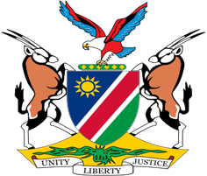

Statement by Mr. Colin Namalambo, Charge d’ Affaires, 37th session, UPR outcome of Mauritania, 19 January 2021

- Thank You Madam President,

- Namibia warmly welcomes the esteemed delegation of Mauritania to the UPR and thank them for submitting their national report as well as for the additional information provided today.

- We commend Mauritania for the positive Human Rights impacting measures taken during the period under review which includes the adoption of legislation on the Prevention and Punishment of Trafficking in Persons and the Protection of victims.

- In the spirit of constructive dialogue, Namibia makes the following recommendations to Mauritania for consideration:

  - Ratify the International Labour Organisation's Violence and Harassment Convention No. 190;

  - Ensure that sentences of persons who remain under sentence of death are commuted without delay.

- Namibia has taken note of Mauritania's appeal for technical assistance, and we, therefore, urge the Office of the High Commissioner for Human Rights to enhance the provision of technical assistance to Mauritania.

- We wish the delegation a successful review.

- I thank you Madam, President.

