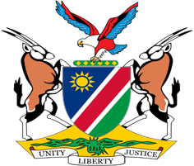

Statement by Mr. Colin Namalambo, Charge d’ Affaires, 37th session, UPR of Georgia, 26 January 2021

- Thank You Madam President,

- Namibia extends a cordial welcome to the esteemed delegation of Georgia and thank them for submitting a voluntary national report in 2019 as well as a national report containing detailed information on the progressive measures taken since its last review to protect the human rights of persons on its territory.

- We have taken note of these progressive measures and particularly applaud Georgia for amending its laws in 2019 to regulate sexual harassment in labour relations and to further improve the rights of women and girls.

- Having taken note of the progress made, we make the following recommendations to Georgia for consideration.

  - Strengthen efforts to combat gender-based violence, including domestic violence and femicide;

  - Increase women representation in political and public life, especially at senior and decision-making levels;

- We wish the delegation a successful review.

- I thank you Madam President.

