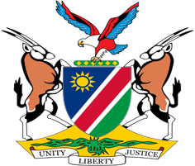

Statement by Mr. Colin Namalambo, Charge d’ Affaires, 37th session, UPR of Austria, 20 January 2021

- Thank You Madam President,

- Namibia welcomes the esteemed delegation of Austria and thank them for their commitment to the UPR process.

- Namibia commends Austria for the human rights impacting measures taken during the period under review. We particularly note the adoption of measures aimed at combating racism, hate crimes, and hate speech.

- There, however, remain room for improvement, and in the spirit of constructive dialogue we the make the following recommendations for consideration by Austria:

  - Strengthen measures to combat racism, hate crime, and hate speech, including by adopting a national plan of action against racism;

  - Ratify the International Labour Organisation Violence and Harassment Convention of 2019;

- We wish the delegation a successful review.

- I thank you Madam President.

