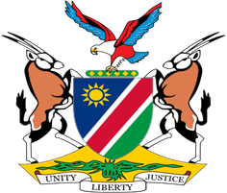

Statement by Mr. Colin Namalambo, Charge d’ Affaires, 37th session, UPR of Australia, 20 January 2021

- Thank You Madam President,

- Namibia warmly welcomes the esteemed delegation of Australia and thank them for submitting a comprehensive national report on the positive human rights measures taken since the last review.

- We particularly commend Australia for the measures taken to promote and protect the rights of women, children, and indigenous peoples. There, however, remains room for improvement and in the spirit of constructive dialogue we make the following recommendations for consideration by Australia:

  - Withdraw the reservation to Article 20 of the International Covenant on Civil and Political Rights;

  - Develop a national plan of action to implement the principles in the United Nations Declaration on the Rights of Indigenous Peoples.

- We wish the delegation a successful review.

- I thank you Madam President.

