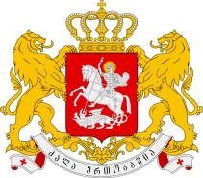

Closing Statement by H.E. Ms. Khatuna Totladze
Deputy Minister of Foreign Affairs of Georgia
37th Session of the UPR Working Group of the UN Human Rights Council
26 January 2021

Madam President, Excellences, Ladies and Gentlemen,

On behalf of the Georgian delegation I would like express my gratitude to the representatives of the UN member states for their constructive participation in the review of Georgia, for their questions and recommendations.

We appreciate the incredible work done by Troika, namely by Czech Republic, Denmark and Namibia. I thank the Office of Public Defender of Georgia and civil society organizations for their contributions to the review. I also would like to express my gratitude to the President of the Human Rights Council and to the Secretariat.

I believe that online format of the discussion has not impeded our efforts to productively discuss the human rights situation in Georgia. Despite the shortage of time, I hope that we have managed to cover significant part of the questions. We will examine recommendations carefully and I am confident that we will be able to except many of them.

I assure you that we will proceed to the follow-up process in a good faith and in a close dialogue with all relevant stakeholders.

Thank you very much for your kind attention.

