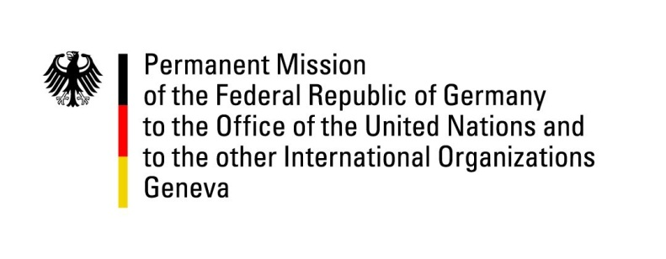

United Nations Human Rights Council
28th Session of the UPR Working Group

Geneva, 13th November 2017

German recommendations and advance questions
to
Zambia

Mr. President,
Germany commends Zambia for its cooperation with international human rights institutions.

Germany highly appreciates Zambia’s commitment to alleviating the refugee crisis on the border with the DRC.

Germany also praises Zambia’s announced approval of the moratorium on the use of the death penalty. This goal could also be reached below the threshold of a constitutional amendment, by amending the Zambian criminal law: the compulsory sentencing of the death penalty for murder, heavy robbery and high treason would have to be replaced by life imprisonment.

Germany recommends:

1. In combatting 'violence against women and girls', Zambia should swiftly and fully implement the 'Convention on the Elimination of All Forms of Discrimination against Women'. This also includes the full implementation of the so-called 'Anti-GBV Act' of 2011 and the allocation of adequate budget resources for an 'anti-GBV fund'.

2. Since Zambia has one of the highest birth rates, Germany recommends to develop and implement a comprehensive strategy on population and education policies, in line with economic, social and cultural rights.

Thank you.

Advance Questions:

- The so-called 'Public Order Act' requests organizations such as parties or non-governmental organizations to announce planned meetings or demonstrations. In many instances, particularly regarding events of opposition parties or demonstrations, these were prohibited with reference to public security. How does Zambia plan to ensure that the rights to peaceful assembly and freedom of expression enshrined in the Zambian constitution can be exercised freely and without restrictions?

- The so-called 'Public Order Act' requests organizations such as parties or non-governmental organizations to announce planned meetings or demonstrations. In many instances, particularly regarding events of opposition parties or demonstrations, these were prohibited with reference to public security. How does Zambia plan to ensure that the rights to peaceful assembly and freedom of expression enshrined in the Zambian constitution can be exercised freely and without restrictions?

