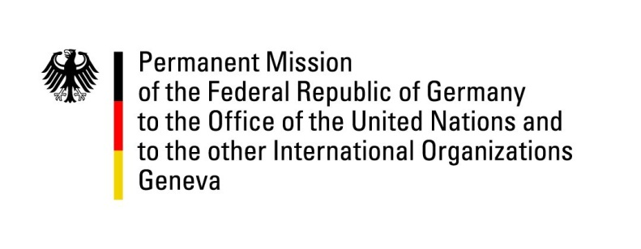

United Nations Human Rights Council

28th Session of the UPR Working Group

Geneva, 15 November 2017

German questions and recommendations to

Ukraine

Thank you Mr President,

Germany welcomes the delegation of Ukraine to the UPR. While we commend Ukraine on the implementation of UPR-recommendations, especially in the situation of juvenile prisoners, Germany continues to remain concerned about some human-rights issues and offers the following recommendations:

1. Continue efforts to improve the situation of prisoners, in particular in pre-trial-detention, by inter alia, increasing the minimum space attributed to each prisoner, allocating necessary financial means, increasing custodial staff and ensuring necessary medical treatment.

2. Complete the judicial reform and the anti-corruption policy by reforming the Prosecutor Generals’ Office, reforming the State Security Service (SBU) according to international standards as drawn up with the support of Euro-Atlantic institutions and introduce, as foreseen in the relevant legislation, specialized anti-corruption courts.

3. Further strengthen the protection of rights of minorities, including LGBTI and the Roma community by effective implementation of existing legislation and consequent law enforcement.

I thank you, Mr President.
QUESTIONS SUBMITTED IN ADVANCE:
1.Germany welcomes the ongoing prison reform and commends Ukraine for the efforts already made to improve the situation of prisoners, in particular of juvenile prisoners. However, with regards to still existing shortcomings in the penitentiary system, including in pre-trial detention, mentioned in the last report of the CPT?
Germany would like to know by which means Ukraine will guarantee that prisoners obtain necessary medical treatments and how Ukraine will ensure that necessary financials means will be allocated in order to permit urgent repairs.
2. More than three years after the events, the perpetrators of the crimes at the Maidan and on May 2nd, 2014, in Odessa have not been brought to justice. According to OCHCR reports, neither have perpetrators of grave violations of human rights in the government-controlled zone of conflict been brought to justice.
Which initiatives Ukraine will take to improve the effectiveness of the law-enforcement system as to exclude impunity regarding grave violations of human rights?
3. Germany commends Ukraine for improvements regarding the situation of the LGTBI community. Notably the Kyiv Pride events of 2016 and 2017 were successful. However, we are worried about reports of aggression against members of the community in smaller villages and rural areas and of attacks against peaceful assemblies. Reports about lack of effective law enforcement adds to our worries.
Therefore, we would like to know by which means the rights of LGBTI in the country at large are to be protected?
4. The Roma minority is still victim of discrimination and violent attacks.
By which means Ukraine will protect their rights?

