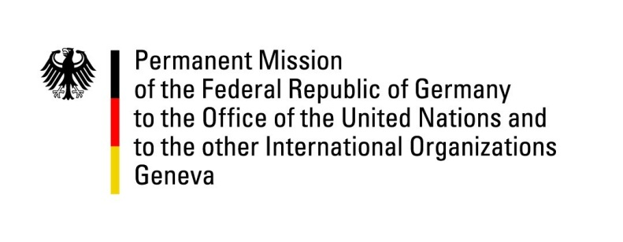

United Nations Human Rights Council
28th Session of the UPR Working Group

Geneva, 15 November 2017

---
German recommendations and questions
to
Sri Lanka

Thank you Mr. President,
Germany welcomes the overall positive development with respect to the promotion and protection of human rights in Sri Lanka since 2015 in general and in particular the recent establishment of the Office of Missing Persons (OMP). Germany encourages the Government not to lose momentum in fulfilling all its commitments made in HRC Res. 30/1 including those on transitional justice.

Germany recommends:

- Make the OMP fully operational inter alia by appointing well-qualified independent commissioners and allocating sufficient funds.
- Take the necessary legislative steps to establish a Commission for Truth, a Judicial Mechanism and an Office for Reparations as specified in resolution 30/1.
- Ensure the independence and integrity of the authority and division for witness and victim protection and allocate sufficient funds beginning with the 2018 budget.
- Develop a clear timeline and benchmarks for the full implementation of Sri Lanka’s commitments under HRC Resolution 30/1.

I thank you Mr. President.

Advance questions

- In September 2017, the parliament of Sri Lanka has taken the bill on enforced disappearances from its agenda. Why was this the case and when does the parliament plan to reconsider the bill?
- Has there been any progress or are there any plans to establish a publicly accessible central register for all persons missing or in custody as previously recommended?
- Poverty levels are still high, especially in the North, East and Uva Provinces. What concrete measures has the government taken to improve the living conditions of the poor and to bring them into work?
- What steps has the government taken to make the CRPD ratified in 2016 operational, in particular its Article 33? Does it intend to ratify its Optional Protocol?
- Does the Government of Sri Lanka plan to include the rights of LGBTIQ persons and address sexual and gender-based violence in the final version of the National Human Rights Action Plan (2017-2022)? If not, for what reason?

