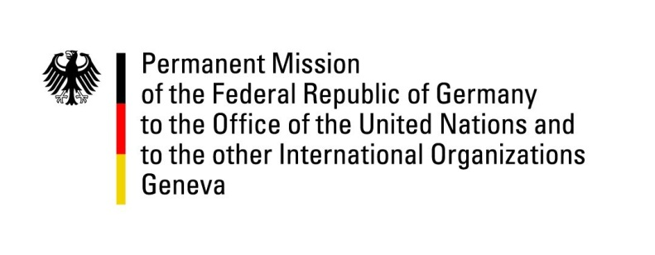

United Nations Human Rights Council

28th Session of the UPR Working Group

Geneva, 8th November 2017

German questions and recommendations to

Peru

Mr. President,
While we appreciate Peru’s recent progress on several issues, most notably the adoption of the law regarding the Search for the Disappeared (N°30470). Germany continues to be concerned regarding several human rights issues leading to the following recommendations:

- Guarantee the Indigenous Peoples’ right to free, prior and informed consent and ensure they receive land titles, also in remote regions.

- Implement the National Plan on the Search for the Disappeared and provide the financial resources necessary to satisfy the human dignity of the Disappeared and their relatives.

- Include victims of sexual violence in the reparation program “Programa Integral de Reparaciones”.

Thank you.

Questions submitted in advance:
- Germany commends Peru on the adoption of the law N°30364 on violence against women. What are the measures taken to ensure its effective implementation?
- What actions is Peru taking to improve the protection of and necessary support for human right defenders so these are able to safely continue with their work?
- Which specific measures is Peru taking in order to ensure the rights of Indigenous Peoples and peasants and protect them from violence even in remote regions?
- How does Peru plan to tackle terrorist activities and their supporters while safeguarding the rule of law and international human rights standards?

