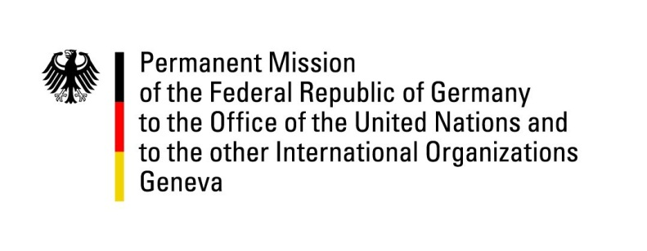

United Nations Human Rights Council

28th Session of the UPR Working Group

Geneva, 13 November 2017

German questions and recommendations to
Pakistan

Thank you, Mr. President,

Germany remains deeply worried about the human rights situation in Pakistan. The fight against poverty, despite considerable progress, remains a huge challenge, reflected in the alarming numbers of children suffering from malnourishment and lack of education, which threatens to perpetuate their plight. Despite some positive examples of new legislation, notably the Punjab Protection of Women against Violence Act, women and children continue to suffer from widespread discrimination and violence. So do religious minorities.

The lifting of the moratorium on the death penalty, followed by unprecedented numbers of executions, many of which based on secret trials, in breach of international human rights standards, is a significant step backwards.

These concerns lead to the following recommendations:
- Take measures to considerably reduce the number of stunted children and out-of-school children, and end child labor by developing indicators and a timeline for the implementation of the recent legislation against child labor.
- Develop indicators and a timeline for the implementation of the recent legislation on women rights, and ratify the Optional Protocol to the CEDAW.
- Conduct an independent inquiry into all suspected cases of enforced disappearance of human rights defenders and hold accountable those responsible.
- Reinstate the moratorium on executions, and ban the death penalty for defendants who suffer from mental illness or were minors at the time of their alleged crimes.

I thank you, Mr. President.
GERMAN ADVANCE QUESTIONS TO PAKISTAN
- How is Pakistan tackling the persisting issue of enforced disappearances and would it consider including enforced disappearances as a specific crime into the Pakistan Penal Code, and to ratify the International Convention for the Protection of All Persons from Enforced Disappearances?
- What has Pakistan done regarding recommendations it received in the second UPR cycle on reviewing public school curricula in order to eliminate prejudice against religious and other minorities?
- Has Pakistan undertaken any steps to protect the rights of defendants accused of blasphemy, considering the risk that the blasphemy law is abused to settle personal scores or to target religious minorities?
- Which measures has Pakistan taken to fight against widespread cases of arbitrary arrest, torture and other ill-treatments?
- Considering the end of the moratorium on executions was presented as a measure against terrorism, while many inmates on death row were sentenced for crimes not related to terrorism: Has Pakistan taken any steps to reduce the number of crimes for which the death penalty is awarded?

