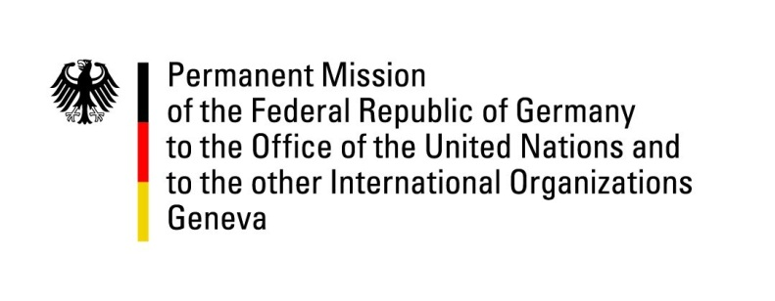

United Nations Human Rights Council

28th Session of the UPR Working Group

Geneva, 8 November 2017

German recommendations to

Guatemala

Mr President,

Germany commends Guatemala’s achievements with regard to a number of human rights issues – raised in the second UPR –such as the rights of indigenous peoples, and violence against children. Germany appreciates the fact that civil society is taking a stand against corruption and impunity, while we have taken note of President Morales’ request to renegotiate the mandate of the International Commission against Corruption (CICIG) within the framework of the United Nations. Germany wishes to emphasise that, to this day CICIG – especially under the leadership of Iván Velásquez – has played a major role in promoting the rule of law and in opening new channels of communication with civil society. Germany remains concerned about a number of serious human rights issues and, therefore, offers the following recommendations:
- Strengthen the independence and the effectiveness of the judiciary and adopt all necessary measures to consolidate recent efforts in the fight against impunity.
- Support the work of civil society by implementing public policies to protect it and end the misuse of penal and administrative law against human rights defenders, including indigenous peoples’ rights defenders, especially in the context of hydroelectric and mining projects.
- Adopt effective measures to address widespread child pregnancy and ensure access to sexual and reproductive health rights, as well as education programmes.
- Back efforts to counter child malnutrition and continue to strengthen programmes to eradicate poverty and extreme poverty.

Thank you.

