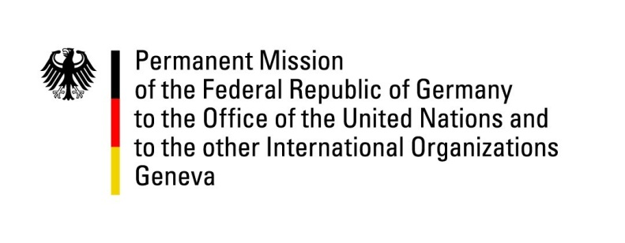

United Nations Human Rights Council
28th Session of the UPR Working Group

Geneva, 7 November 2017

----

German recommendations to Ghana

Mr. President,
Germany commends Ghana for social and economic progress made, further strengthening of civil rights and the inclusive consultations held with civil society to prepare the UPR.

Germany offers the following recommendations:

- Continue the current practice of granting clemency and commuting death sentences, establish an official moratorium on executions and continue the public discourse to finally abolish the death penalty.
- Intensify efforts to prevent violations of children’s rights and accelerate the adoption and implementation of laws prohibiting harmful practices against women and girls, including trokosi and female genital mutilation.
- Decriminalize same-sex sexual relations between consenting adults by repealing Section 104 (1) (b) of the Criminal Code and introduce comprehensive anti-discrimination legislation to provide equal protection against discrimination for all persons and on all grounds.

Thank you.

Advance Questions

- Germany is concerned about the protection of all persons from discrimination. Which measures have been taken and will be taken to uphold the fundamental principles of equality and non-discrimination as set out in the Constitution of Ghana and international Human Rights Instruments and to ensure non-discrimination of LGBTI people as well as to prevent and prosecute violent attacks against this group?
- Germany welcomes the ratification of the Optional Protocol to the United Nations Convention against Torture and Other Cruel, Inhuman or Degrading Treatment or Punishment (OPCAT), but is concerned that conditions in Ghana’s prisons have not sufficiently improved since the last UPR. How is Ghana addressing overcrowding and the lack of rehabilitation programmes? What steps is Ghana taking to establish a national preventive mechanism as prescribed in the Optional Protocol to the Convention against Torture?
- Germany is concerned about the precarious situation of disabled people in Ghana, particularly with regard to underfunding and a general lack of state-run medical facilities and qualified personnel leading to inappropriate treatment of disabled people not least in so-called “prayer-camps” What is Ghana doing to improve this situation and limit non-consensual psychiatric treatment?
- Germany welcomes progress made by Ghana in the area of sexual and reproductive health. Which steps are being undertaken toward the adoption of the validated Comprehensive Reproductive Health Education Guidelines? Which steps are being taken to improve schools' wash facilities (WASH programme), in line with the Education Strategic Plan (2010 – 2020) to foster menstrual hygiene management and tackle girls school dropouts?

