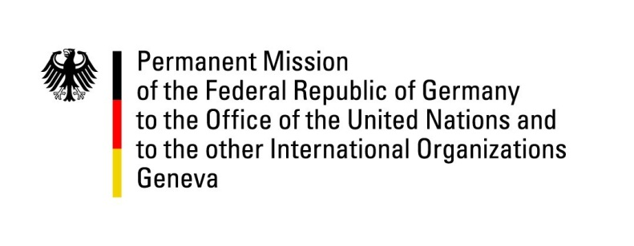

United Nations Human Rights Council

28th Session of the UPR Working Group

Geneva, 7 November 2017

---

Gabon

Germany’s recommendations
and advance written questions

Mr President,

Germany welcomes the delegation of Gabon to the third cycle of the UPR and appreciates that Gabon has called the International Criminal Court to investigate the riots during the 2016 elections. However, Germany is of the opinion that the establishment of an independent and meaningful inquiry into the post electoral violence would also be important.
In addition, Germany offers the following recommendations to Gabon:

- As violations of international standards of imprisonment still prevail and have not been sufficiently addressed since our last recommendation in 2012, we recommend Gabon again to improve the conditions in prisons and to review the extraordinarily long period of investigation (up to 18 months) as well as the limited access to visit prisoners.

- Repeal or amend Law 19/06/2016, which entered into force at the beginning of 2017, in order to guarantee the constitutionally enshrined human rights to freedom of the press and of freedom of opinion and expression, as both are necessary preconditions for a democratic and active society

I thank you, Mr President.

Advance written questions

- Which measures have been taken to improve prison conditions since 2012?

- Considering the restrictions imposed by regulation No. 19 dated June 9, 2016, how does the government of Gabon ensure freedom of press?

