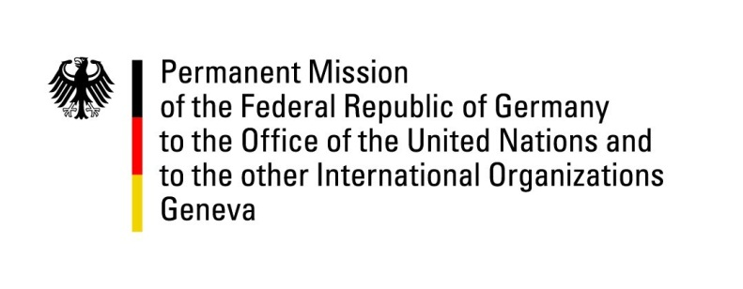

United Nations Human Rights Council

28th Session of the UPR Working Group

Geneva, 6 November 2017

German questions and recommendations to

Czech Republic

Mr. President,
Germany welcomes the delegation of the Czech Republic to the third cycle of the UPR and wishes to commend the government for its persisting commitment to promote freedom and human rights. We particularly welcome the adoption of the 2012-2020 National Strategy to Protect Children’s Rights, including the commitments to develop foster care systems. Germany offers the following recommendations:
- Promote more tolerance towards minorities and respect for their human rights through civic educational campaigns in traditional and social media.
- Take all necessary steps to end discrimination and to improve the living conditions of the Roma population, inter alia through the provision of adequate housing and public infrastructure.

Questions submitted in advance:
- Which concrete steps are being taken to implement the 2012-2020 National Strategy to Protect Children’s Rights?
- With regard to the rights of Roma women in the Czech Republic, what political and legal actions have been carried out to adopt a compensation mechanism for victims of compulsory sterilizations?

