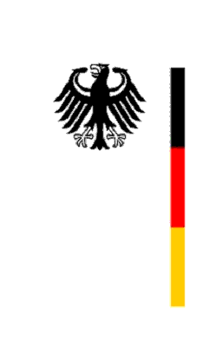

United Nations Human Rights Council

28th Session of the UPR Working Group

Geneva, 9 November 2017

BENIN

---

Germany’s recommendations and questions submitted in advance

Mister President,
Germany appreciates the numerous efforts the Republic of Benin has undertaken to implement the recommendations given in the second cycle of the UPR and the constructive way in which it is dealing with them.
However, Germany is concerned about remaining human rights violations and would like to offer the following recommendations:

- Support the efforts of the judiciary to effectively implement the adopted reforms by ensuring adequate financial support of the justice ministry as foreseen in the National Development Plan in the Area of Justice.
- Strengthen the efforts to effectively fight child labour and child trafficking by taking more preventive measures and implementing more punitive measures.
- Significantly strengthen the cooperation between the different actors of the judiciary to avoid long pre-trial detention and to ensure every citizen’s right to a fair trial in due time.
- Continue improving the often still miserable conditions in Benin prisons.
- Step up efforts to more efficiently implement the prohibition of FGM in all areas of the country and among all groups of citizens.
- Make the National Human Rights Commission operational.

Thank you, Mr. President.

Advance written questions

- Which concrete measures is Benin taking to effectively reduce the often still very long periods of pre-trial detention?
- Which measures is Benin taking to effectively ensure the functioning of Benin’s Human Rights Commission?
- Which concrete measures is Benin taking to step up its efforts to prevent and fight child labour and child trafficking?
- Which measures is Benin taking to make sure that the prohibition of FGM will be effectively implemented in all parts of the country, including in rural areas?

