Check against delivery

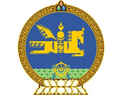

28th Session of the UPR Working Group
Mongolia’s statement at the Review of Ghana
7 November 2017

Mr. President,

Mongolia welcomes the distinguished delegation of Ghana and thanks for the presentation of the national report.

Our delegation welcomes the decision by the Government of Ghana to abolish death penalty and commend the Government to campaign and raise public awareness of the necessity to abolish this cruel practice. We hope the people of the country will vote against death penalty.

Our delegation notes the efforts of the Government to strengthen the right to education, promote gender equality and eliminate discrimination against women.

I thank you Mr. President.

