Check against delivery

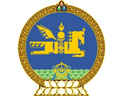

28th Session of the UPR Working Group
Mongolia’s statement at the Review of Zambia
13 November 2017

Mr. President,

Mongolia welcomes the distinguished delegation of Zambia and thanks for the presentation of the national report.

We recommend Zambia to

- Ratify International human rights instruments, which are not ratified,

- Strengthen its efforts in abolishing death penalty by law,

- Continue its efforts to provide universal access to education

I thank you Mr. President.

