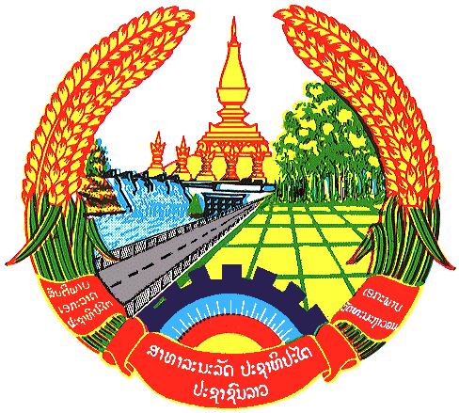

Statement by the delegation of the Lao PDR
At the 28th Session of UPR Working Group
Geneva, 06 - 17 November 2017
----------------

Review of Sri Lanka: 15 November 2017, at 14:30 - 16:00 hours

Mr. President,

The Lao delegation warmly welcomes the delegation of Sri Lanka to the 28th Session of the UPR Working Group and would like to thank for the comprehensive presentation of the National Report.

My delegation is pleased to note that the Government of Sri Lanka has officially launched the National Human Rights Action Plan (NHRAP) 2017- 2021; We also note Sri Lanka’s efforts to create favorable conditions for people to further exercise their fundamental rights and freedom by amended constitution, enacted or amended number of national legislations on human rights, and ratified the Convention on the Rights of Persons with Disabilities (CRPD), among others.
Lao PDR commends efforts made by the Government of Sri Lanka towards promoting rights of vulnerable groups including women, children and person with disabilities, and enhancing rights to education by introducing regulations on 16 years of compulsory education, and implementing polices supporting free education for all children from Grade 1 to university level.
Recommendation
- To continue efforts to address discrimination again women and combating gender based violence, and
- To ensure equal access to education of vulnerable people including women, children and persons with disabilities.

We wish Sri Lanka every success in its Third Cycle of the UPR review.

I thank you, Mr. President

