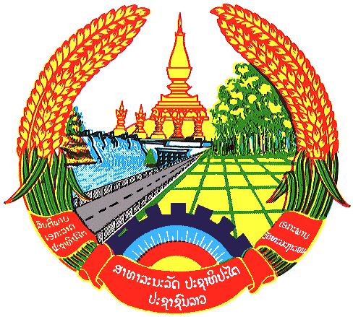Statement
by Lao PDR Delegation
At the 28th Session of the UPR Working Group
Geneva, 6-17 November 2017

Review of Republic of Korea: Thursday 9 November 2017, 14:30 – 18:00

Mr. President

The Lao Delegation warmly welcomes the Delegation of the Republic of Korea to the 28th Session of the UPR Working Group and would like to thank for a comprehensive presentation of the National Report on human rights.

My delegation commends the Republic of Korea (ROK)’s active participation in the work of the Human Rights Council, the UPR process and engaging with the treaty bodies.

Lao PDR welcomes progress made by the Government of the Republic of Korea on promoting rights of vulnerable groups including women and children, strengthening right to health, rights to education and enhancing freedom of expression.
We are pleased to note that the Republic of Korea (ROK) has been implementing the Framework Act on International Development Cooperation, which has provided Official Development Assistant (ODA) to developing countries for the purpose of reducing poverty, promoting the rights of women, children and persons with disabilities, achieving gender equality, and realizing sustainable development.
Recommendation:

- To continue develop measures to ensure non-discrimination against women and achieve gender equality.

- To continue efforts on encouraging cultural exchanges between the residents and migrants and social integration.

We wish the Republic of Korea every success in its Third cycle of the UPR.

I thank you, Mr. President.

