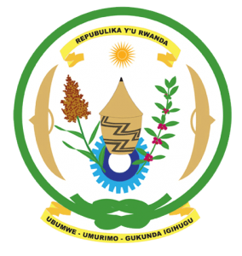
28th Session of the Universal Periodic Review Working Group
Review of Zambia
13th November 2017

Statement by Rwanda delivered by Mr. Moses Rugema

Thank you Mr. Vice-President,
- Rwanda warmly welcomes the delegation of Zambia and thanks them for the presentation of their national report and the oral update just provided by the Honourable Minister of Justice.
- Rwanda welcomes the many positive steps taken by the government of Zambia to promote and protect human rights including through implementation of the recommendations of its second cycle UPR.
- While welcoming efforts to promote women’s rights and to fight sexual and gender-based violence, we however note with concern that gender based violence remains prevalent. We encourage Zambia to strengthen implementation of legislation on gender base violence and ensure justice for victims.

Rwanda recommends that Zambia:
- Take measures to introduce a de jure moratorium on executions and take concrete steps toward the total abolition of the death penalty.
- Ratify the first and second optional protocols to the Convention on the Rights of the Child.

We wish Zambia every success in their review.

Thank you.

