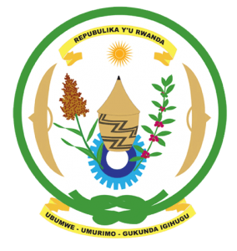
28th Session of the Universal Periodic Review Working Group

Review of Benin

10th November 2017

Statement by Rwanda delivered by Mr. Moses Rugema

Thank you Mr. Vice President,
- Rwanda warmly welcomes the delegation of Benin and thanks them for the presentation of their national report and the update just provided.
- Rwanda commends Benin for its continued efforts to promote and protect the human rights of its people and for the notable progress it has registered in improving the social and economic status of its citizens.
- Rwanda particularly welcomes Benin’s accession to the Convention on the Prevention and Punishment of the Crime of Genocide and looks forward to its entry into force.
- Rwanda encourages Benin to remove from its criminal code all provisions pertaining to the death penalty. In that regard, we are grateful for the updates just provided by the Minister.

Rwanda recommends that Benin:
- Enhance its efforts to strengthen the effectiveness of Benin’s national human rights institution to bring it fully in line with the Paris Principles.
- Strengthen and implement measures to, promote gender equality and equity, address the under-representation of women in decision-making bodies, gender based violence and elimination of harmful traditional practices.
We wish Benin every success in the implementation of the recommendations of this UPR. Thank you

