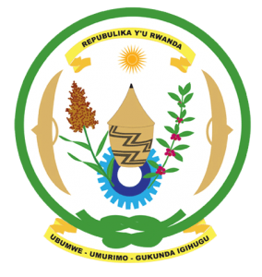
28th Session of the Universal Periodic Review Working Group
Review of Republic of Korea
09th November 2017

Statement by Rwanda delivered by Mr. Moses Rugema
- Rwanda warmly welcomes the delegation of the Republic of Korea and thanks them for the presentation of their national report and the update just provided.
- Rwanda welcomes the Republic of Korea’s commendable efforts to promote and protect human rights including through the adoption of various legislative and policy measures.
- While noting the progress made in combating discrimination against women we encourage the Republic of Korea to enhance those efforts through effective implementation of its Framework Act on Gender Equality.
Rwanda has the following recommendations. That the Republic of Korea:
- Takes measures to introduce a formal moratorium on executions and take concrete steps toward the total abolition of the death penalty.
- Strengthen measures to combat and prevent racism, racial discrimination, xenophobia and related intolerance.
We wish the Republic of Korea every success in the implementation of the recommendations of this UPR.
Thank you

